NIMAA XC Information

Ground conditions
As with any Cross Country, the courses may be subject to change due to wet weather and/or snow. We will update the current state here during the week before the Championships.

Championship notes for the start of each race
Competitors should assemble behind the start area in plenty of time before their race.
Competitors will be allowed into the start area 15 minutes before the beginning of each race.
A warning will be given 3 minutes before each race. At this time, competitors should assemble behind their start pen.
Competitors should listen carefully to any last moment instructions given by the Starter.

Anti-Doping
All NIMAA competitions are subject to the strict anti-doping policies of British Athletics and IAAF.

Health & Safety
Athletes are advised that Health & Safety regulations recommend that you should examine the course for potential hazards before competing.
The course will be checked by the organisers and a risk assessment conducted. A final inspection will be made on the morning of the event and any issues arising will be addressed then.
Any competitor who has concerns about a safety aspect on the course should bring it to the attention of the organisers immediately. If the issue cannot be resolved satisfactorily, the competitor will be advised not to participate in the event.

Photographs and Videos
Photographs of NIMAA events might be published in the athletics press, local media, and on this website.

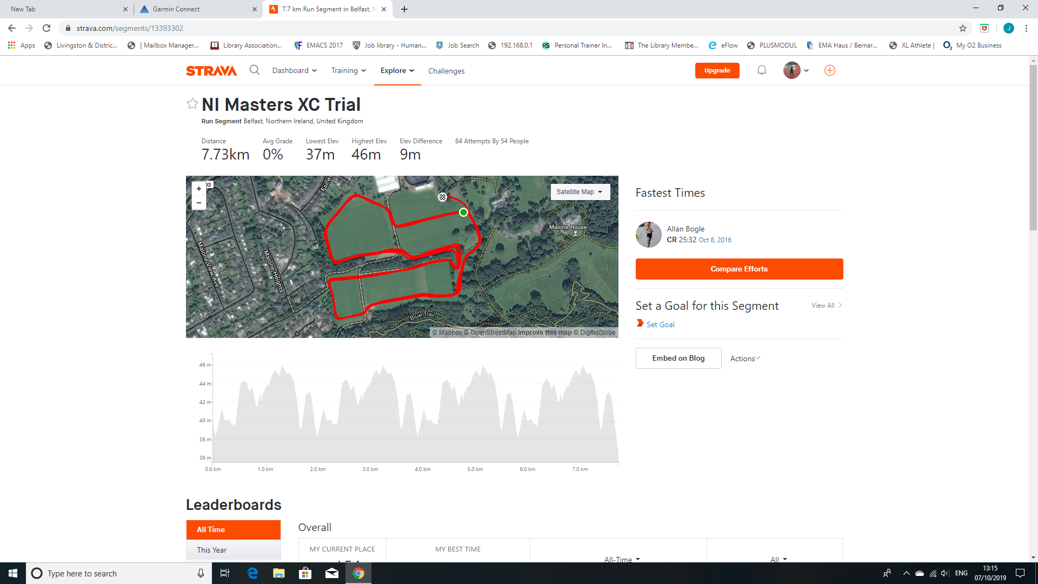
Finish

Start
Gravel Path / Marshals

Car Parking
Car parking is available at Mary Peters Track, the House of Sport, and QUB Turf Changing Rooms and QUB Malone Clubhouse Car Park. Designated Blue Badge parking bays are available at all sites.

The start/finish area is a 5-10 minute walk from the car park at Mary Peters Track, QUB Main Sports Area and House of Sport.
Note 1: Access from Dub Lane to parking at the Turf Changing Rooms is restricted to due to Parkrun, during restricted times 9am-12 an official will be on duty.
Note 2: Please be aware of other users of the car parks – peak times align with parkrun arrival 9am and departure 1030am.
Registration
Registrations will open at 10.45 am at the start/finish area of the course, and will close 15 minutes before the published start time of each race.
Vest numbers should be worn front only and secured with 4 safety pins. Age numbers to be worn on the back.
Timetable
9.30am Course Inspection
10.30am Course Open
10.45am Registration Open
11.30am Lady Masters and Male Masters 65 + (6k)
12.15pm –Male Masters 35 + (8k)
Course Map
A course map is available via the link below and will be printed for inspection on race day.
Toilets / Changing Rooms
Toilets and changing rooms are available at QUB Turf Changing Rooms.
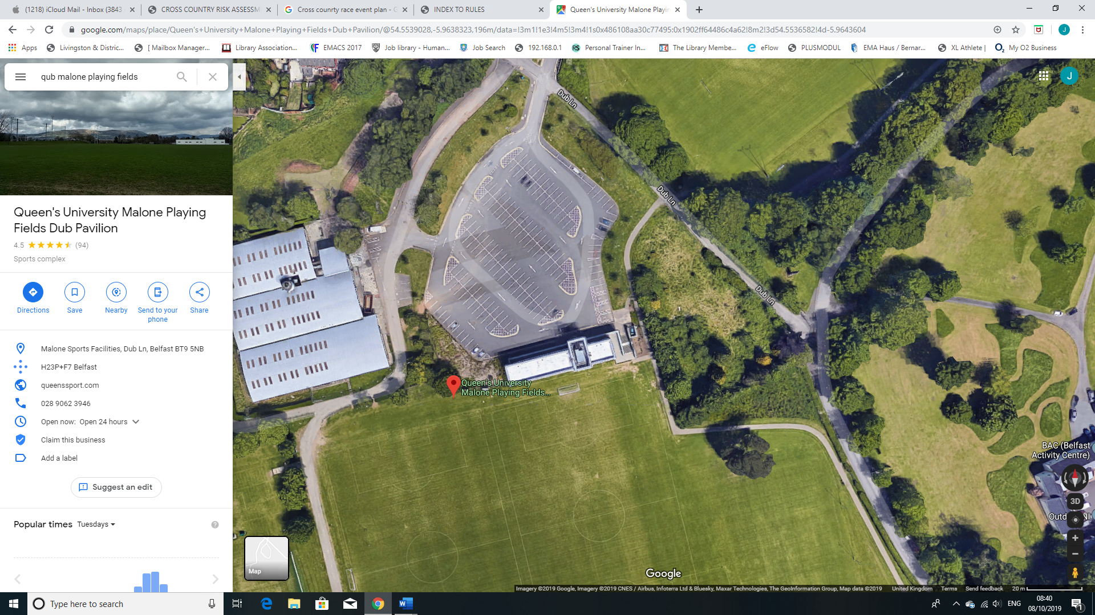
Entry/Car parking – After Parkrun
Other Carparking – Mary Peters Track, House of Sport, QUB
Ambutran (First Aid)

Registration

Toilet Facilities

First Aid/Ambutran

